# Delete List Elements - Final Corrected Python Exercise

Below is the image provided along with the final corrected question, terminal output, and answer:

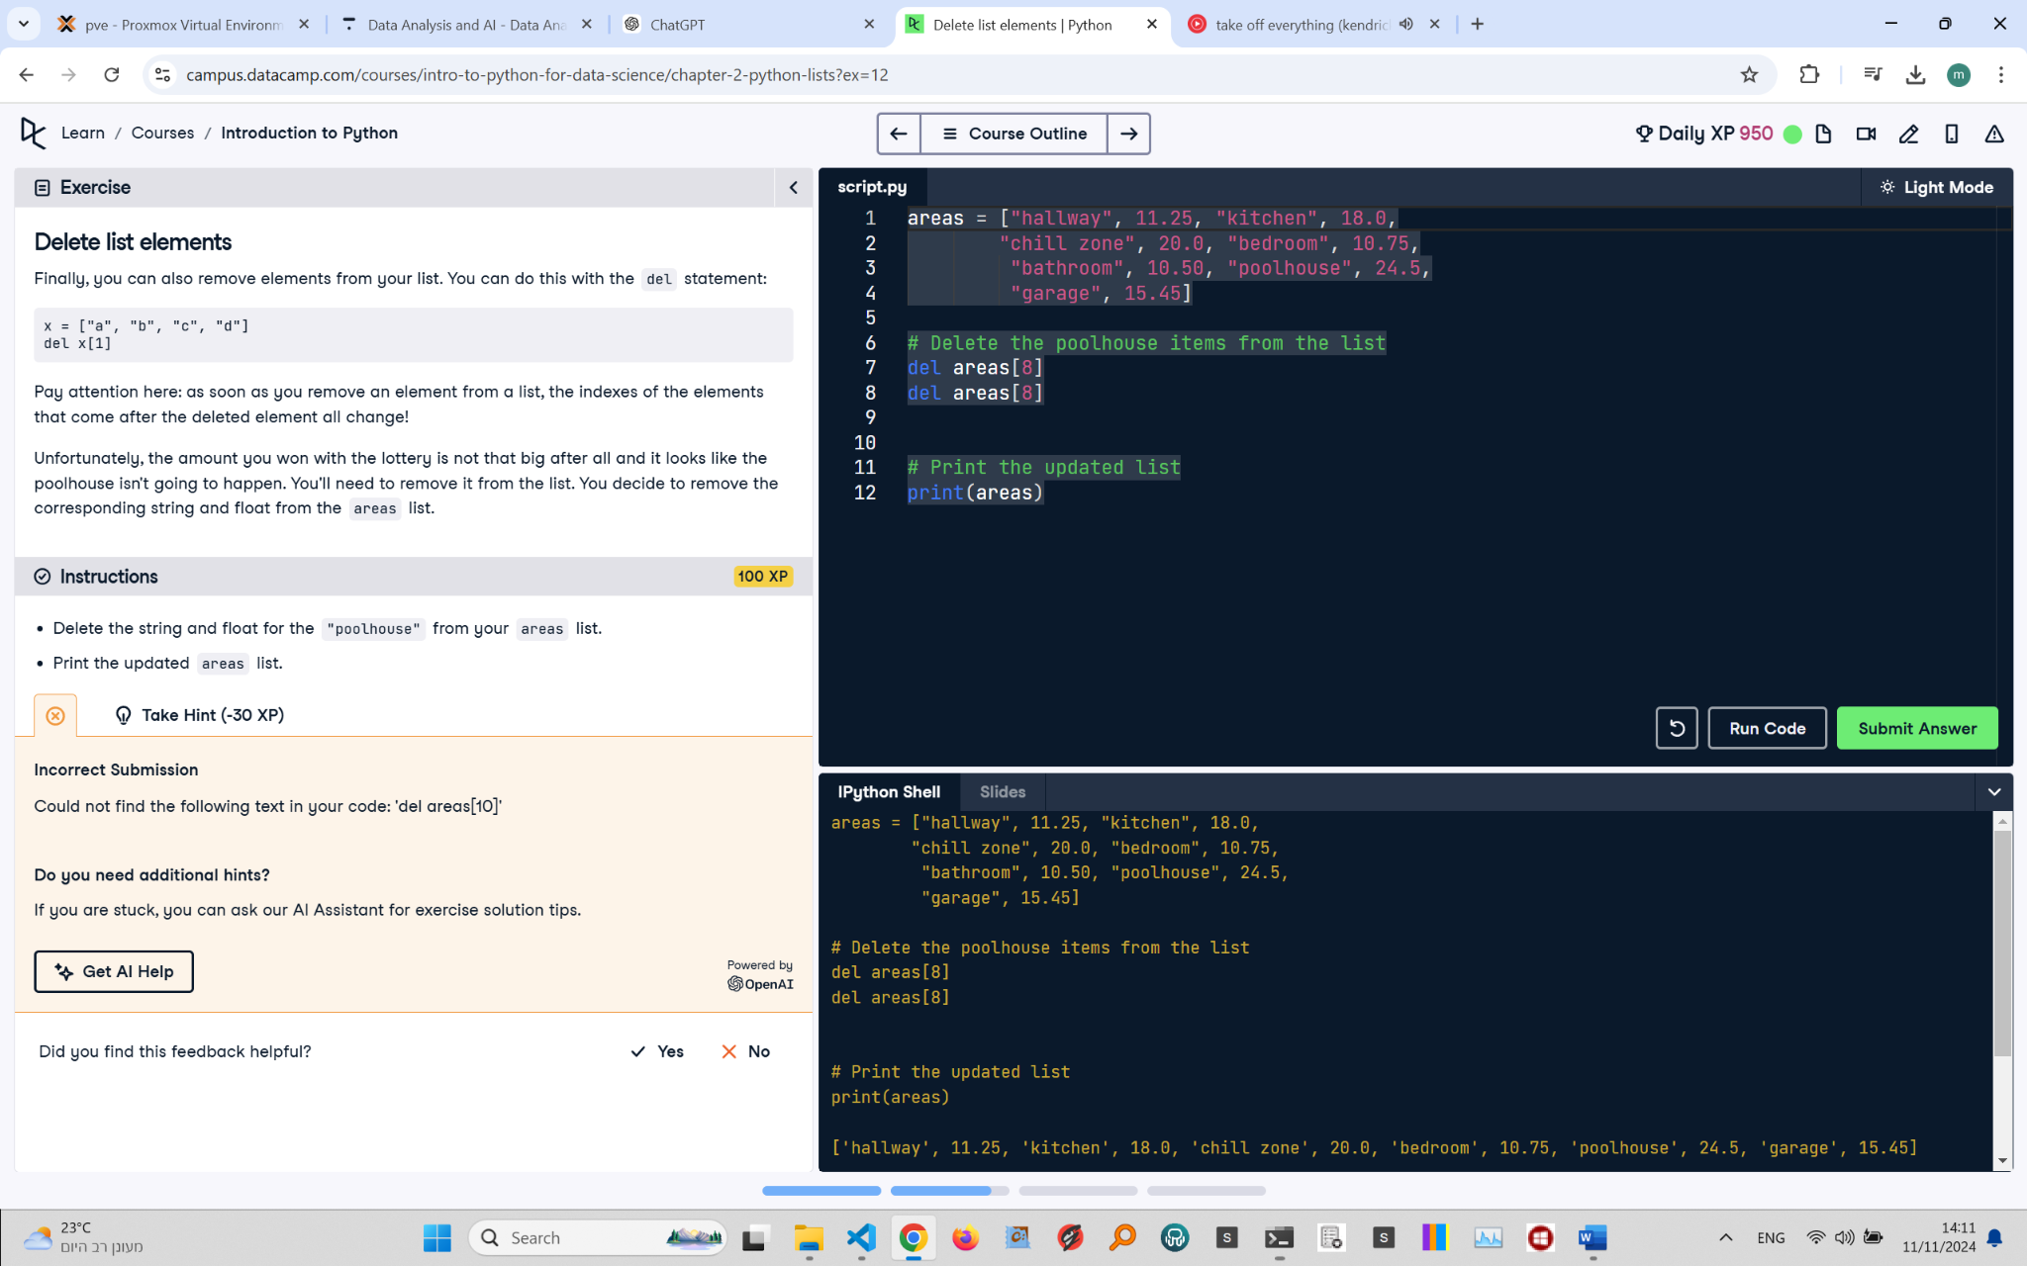

## Final Corrected Question and Terminal

Delete List Elements  
Finally, you can also remove elements from your list. You can do this with the del statement:

x = ["a", "b", "c", "d"]  
del x[1]

Pay attention here: as soon as you remove an element from a list, the indexes of the elements that come after the deleted element all change!  
  
Unfortunately, the amount you won with the lottery is not that big after all and it looks like the poolhouse isn't going to happen. You'll need to remove it from the list. You decide to remove the corresponding string and float from the areas list.  
  
Instructions:  
- Delete the string and float for the "poolhouse" from your areas list.  
- Print the updated areas list.

## Final Corrected Answer

# Create the areas list  
areas = ["hallway", 11.25, "kitchen", 18.0, "chill zone", 20.0, "bedroom", 10.75, "bathroom", 10.50, "poolhouse", 24.5, "garage", 15.45]  
  
# Delete the poolhouse items from the list using slicing  
del areas[10:12]

# Print the updated list  
print(areas)

## Explanation of the Final Corrected Answer

The code uses the del statement with slicing to remove elements from the areas list. del areas[8:10] deletes both "poolhouse" and 24.5 in one command. This approach is efficient and ensures the correct elements are removed. The updated list is then printed.